Internal assessment help sheet
Criteria and weighting
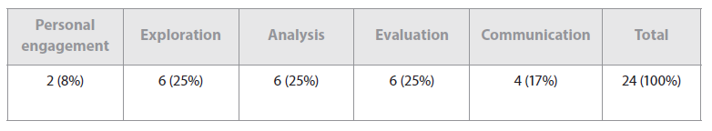

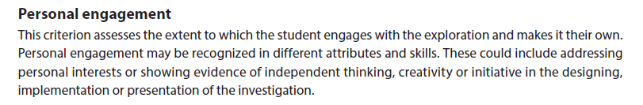
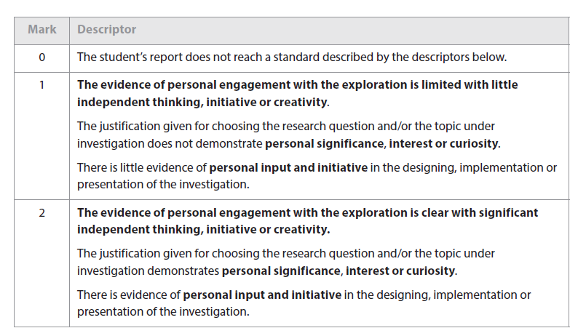
Guidelines for Personal Engagement
- Clearly describe what inspired you to do the investigation
- Why is your investigation important?
- Possible ways to show engagement: Use of multiple ways to investigate the same question; taking the experiment further, if an interesting trend in the data is noticed or a systematic uncertainty is discovered.

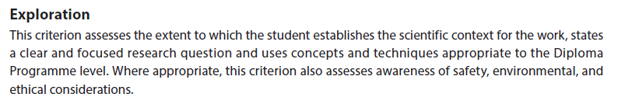
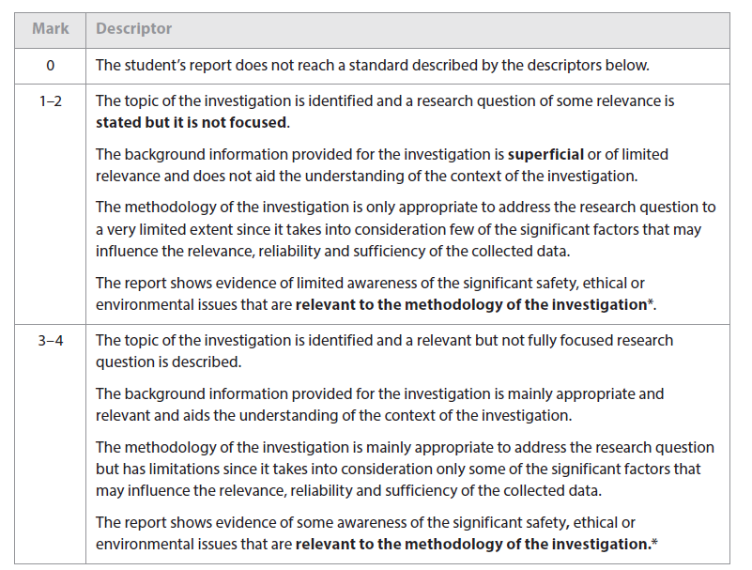
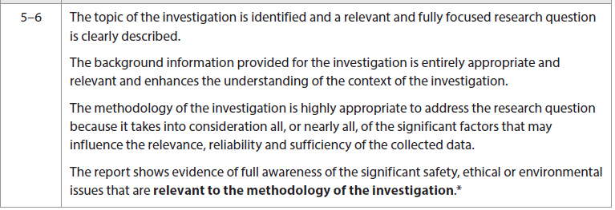
* This indicator should only be applied when appropriate to the investigation
Guidelines for exploration
- State your research question clearly
- Identify the independent variable, the dependant variable and the control variables and make sure it is clear how they are measure and/or controlled
- What is the background science to your research question
- Write your method clearly,include -what equipment you used exactly (i.e. 10cm³ measuring cylinder), the step by step method (clear enough so someone could use it to repeat your experiment), how you controlled your variables
- Quote any sources you used
- Make sure you have enough data points to determine trends and enough trials
- Show you understand the safety, health and environmental issues connected with your experiment

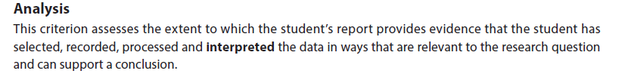
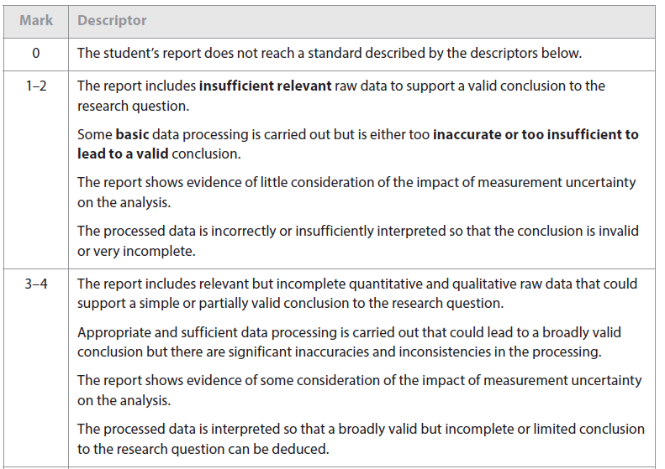
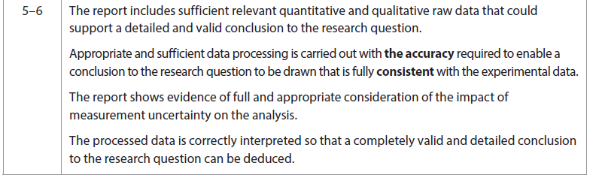
Guidelines on Analysis
- Make sure you include all your raw data (what you read from the equipment used) quantitative (numbers) and qualitative (observations)
- Make sure your tables have titles and that the table headings are clear. Never use the the word amount! Never split tables between pages
- Put your uncertainties in the table headings and make sure your data matches up with them
- Graphs need titles and their axis should be clearly and correctly labelled. The scale should be appropriate. The data points should be accurately plotted and the correct trend lines drawn.
- Measurements taken from the graph should be shown on the graph
- Clearly show how you carried out your calculations including averages and make clear any assumptions you made
- Make sure you propagate your errors
- Your final answer (if numerical) should be given to the appropriate number of significant figures and the correct units
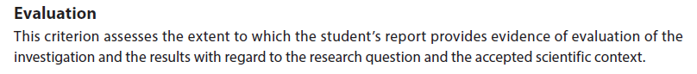
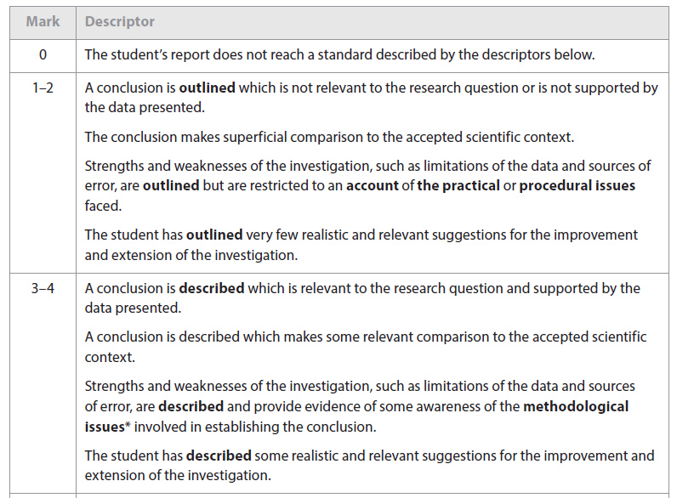
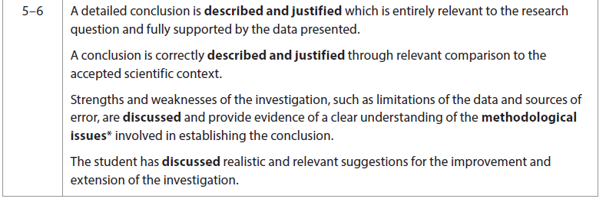
Guidelines for Evaluation
- Make a clear statement of what you found
- Support this by referring to your data
- Discuss how your findings relate to the research question
- How do your findings relate to the science you know
- Compare with data from other sources if possible such as literature values and accepted data sources
- Discuss the strengths of your investigation. What were the good points in your method?
- Discuss the weaknesses in your method This should include :-
- How big were the uncertainties how much did they impact on the results ? (does your result compare well to a known value within your uncertainty tolerances? if not what might have caused this)
- Think about the assumptions you made in the experiment -how much did they impact on your results?
- Where there any major systematic errors did they make the readings above or below what they should have been?
- Could you have controlled your variables better
- Comment on both accuracy and precision
- Finally which out of the above made the biggest impact?
- Taking your discussion of the weaknesses how could they be improved? How much would the suggestions you make impact on the results? Make sure your suggestions for improvement actually relate to the weaknesses you have identified
- What possible extensions could you make to the investigation?
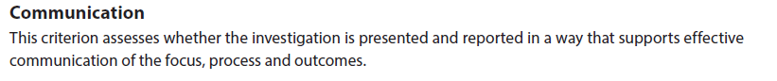
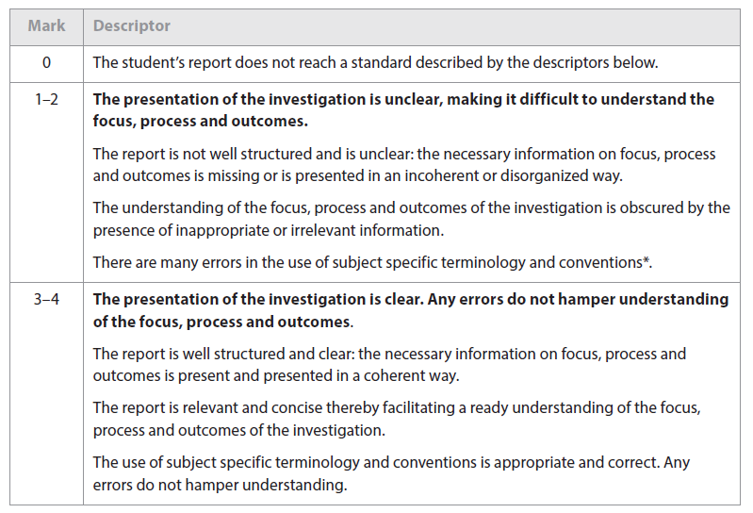
Guidelines for communication

- Use the language appropriate to the subject - use the correct chemical names and formula, correct reference to laws
- Find out and use the correct biological names of any organisms you use; this includes potatoes, apples, yeast.
- Write the names correctly; capital letter for Genus, lower case for species [ if known], always written in italics when typed [underlined if written by hand] ex. Loxodonta cyclotis
- Present graphs and tables well (use appendices if there are large quantities of raw data rather than including them in the core text)
- Reference everything
- If you do drawings, make sure they are fully labelled.

