Reviewing electrolysis
Objective: To review the main ideas covered in electrolysis
Key words: Electrolysis, Electrode, Electrolyte, Anode, Cathode, Reduction, Oxidation, Half equation
Activity
Follow the links given below and answer the questions.
- Follow these links in order. Can you explain the differences observed?
http://www.absorblearning.com/media/attachment.action?quick=u1&att=2152

http://www.absorblearning.com/media/item.action?quick=u2

http://www.absorblearning.com/media/attachment.action?quick=u3&att=2156

- What is an electrolyte? Look at the animation and then write down what this tells you about electrolytes
http://www.absorblearning.com/media/attachment.action?quick=u4&att=2158

- Look at the following video clip showing the electrolysis of Lead Bromide. Explain what you observe.
http://www.absorblearning.com/media/attachment.action?quick=1td&att=4111

- Look at the following clip shows the electrolysis of copper chloride. Explain what you observe in the clip
http://www.absorblearning.com/media/attachment.action?quick=1te&att=4113

- Look at the animation of the electrolysis of aqueous potassium nitrate. What do you observe at the anode and cathode? Write half equations for the reactions. Explain the volume differences in the gases formed.
http://www.absorblearning.com/media/attachment.action?quick=ud&att=2176
- Look at the animation of the electrolysis of brine. Explain what you observe.
http://www.absorblearning.com/media/attachment.action?quick=ug&att=2182
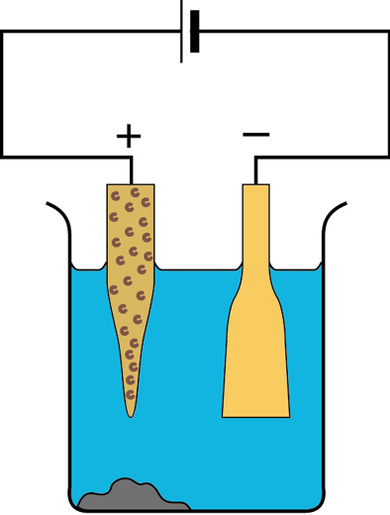
- Look at the following showing the purification of copper. What is the anode and what is the cathode? Explain the process include half equations.. The diagram given can help in your explanation
http://www.absorblearning.com/media/attachment.action?quick=uk&att=2190
http://www.absorblearning.com/media/attachment.action?quick=1tf&att=4115

- Look at the electroplating of nickel in the link below. Draw a similar diagram to show the experiment you did electroplating a nail with copper. Explain what happens in the process. Include half equations.
http://www.absorblearning.com/media/attachment.action?quick=uj&att=2188
- Look at electrolysis of aluminium link below. Follow through all the parts. Have you included all the parts in your account you did foe homework/in class?
http://www.absorblearning.com/media/attachment.action?quick=u8&att=2166
- Look at the table on the next page. Fill in the expected products of electrolysis and write the half equations for the reactions at the electrodes

Electrolysis of solutions challenge
Electrolyte | Product at anode  (+) | Half equation anode | Product at Cathode (-) | Half equation at Cathode | Remaining in solution
Silver nitrate solution
AgNO_{3(aq)}

Dilute Potassium iodide solution KI_{(aq)}

Concentrated sodium bromide solution
NaBr_{(aq)}

Concentrated magnesium chloride solution MgCl_{2(aq)}

Concentrated sodium sulfate solution Na₂SO_{4(aq)}

Dilute copper chloride solution CuCl_{2(aq)}

