Topic 13 Carbonates

Carbonates are compounds that contain the carbonate ion CO₃²⁻ .

- All carbonates are insoluble in water except sodium, potassium and ammonium carbonates.

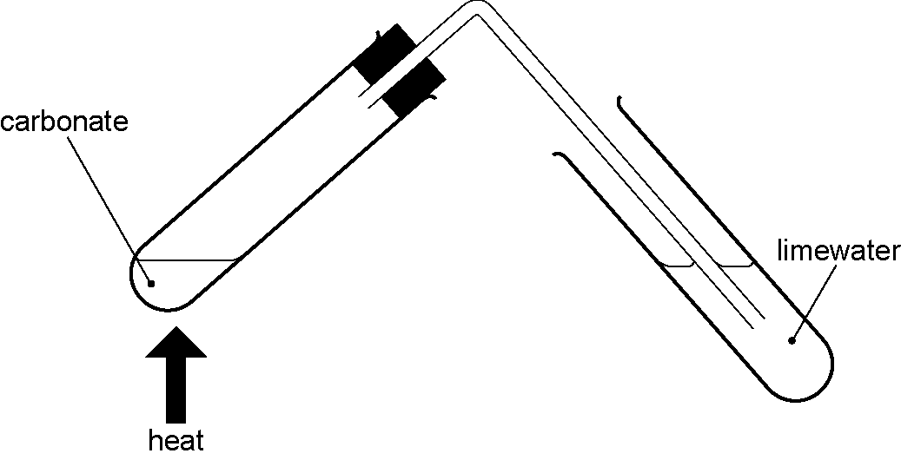
- All carbonates decompose on heating (except sodium and potassium carbonate) to form the oxide and carbon dioxide. This is an example of thermal decomposition , the breaking down of compounds with heating
e.g CuCO₃ → CuO + CO₂

- All carbonates react with acids to produce a salt, carbon dioxide and water. They neutralise acids.
Thermal decomposition
e.g. CaCO₃ + 2HCl → CaCl₂ + CO₂ + H₂O

Limestone
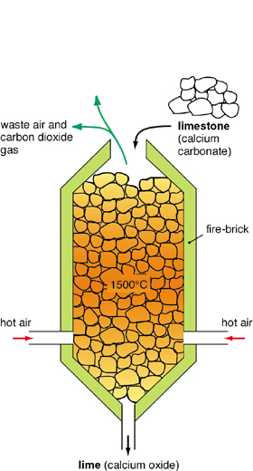
Limestone is a sedimentary rock formed from the shells and skeletons of sea creatures that lived millions of years ago. Limestone is obtained from quarrying and about 5 billion tonnes are quarried every year. The main compound in limestone is calcium carbonate. It has many uses. It can be used as limestone (CaCO₃) or heated in a lime kiln to form lime (CaO, calcium oxide). Lime can then be added to water to make slaked lime (Ca(OH)₂, calcium hydroxide).

In Lime kiln: CaCO₃ → CaO + CO₂

Adding water to Lime : CaO + H₂O → Ca(OH)₂

Slaked lime (Ca(OH)₂, calcium hydroxide) is also called limewater
If carbon dioxide is bubbled through limewater it goes milky. This is because the Calcium hydroxide reacts with carbon dioxide to form insoluble calcium carbonate.
Ca(OH)₂ + CO₂ → CaCO₃

Uses of limestone, lime and slaked lime
Use | Form used | How it is used
Extraction of iron | Limestone | Limestone is added to the blast furnace. In the heat of the furnace it breaks down to calcium oxide and carbon dioxide.  CaCO₃ → CaO + CO₂  The calcium oxide reacts with silicon dioxide (sand), which is one of the main impurities, to form Calcium silicate (slag). This flows to the bottom of the furnace and floats on the iron  CaO + SiO₂ → CaSiO₃
Neutralising acid soil | Limestone, lime of slaked lime | These all react with the acid in the soil to neutralise it
Neutralising flue gas  (desulfurisation) | Powdered limestone or slaked lime | These both neutralise the flue gas. When slaked lime is used it reacts with sulfur dioxide to form calcium sulfite  Ca(OH)_{2(s)} + SO_{2 (g)} → CaSO_{3(s)} + H₂O_{(l)}  The calcium sulfite formed is used to make plaster which is used in building and for broken bones
Road building | Limestone | Used underneath the tar on the road
Cement making | Limestone | The limestone is mixed with clay to make cement. Cement is used to make concrete

